Dual VL53L3CX example with RPI3

Wiring example with two VL53L3CX satellites on Raspberry Pi3 board

# This example relies on vl53lx linux driver built for raspberry pi 3b+ and uses a device tree overlay.

# Device tree overlay

Important note: As 0x29 is the default built-in i2c address the last device listed in the device tree must be set with 0x29 in order to properly set the other device new address.

There is no “power enable” pin set in this example, we choose to connect satellites power supply on the raspberry 3.3V outputs.

Content of duallx.dts file used in the example

/dts-v1/;

/ {

compatible = "brcm,bcm2708";

fragment@0 {

target = <0xdeadbeef>;

__overlay__ {

#address-cells = <0x01>;

#size-cells = <0x00>;

stmvl53lx@30 {

compatible = "st,stmvl53lx";

reg = <0x30>;

xsdn-gpio = <27>;

intr-gpio = <17>;

boot-reg = <0x29>;

};

stmvl53lx@29 {

compatible = "st,stmvl53lx";

reg = <0x29>;

xsdn-gpio = <19>;

intr-gpio = <16>;

boot-reg = <0x29>;

};

};

};

__fixups__ {

i2c1 = "/fragment@0:target:0";

};

};

# VL53L3CX satellites connection on raspberry Pi3

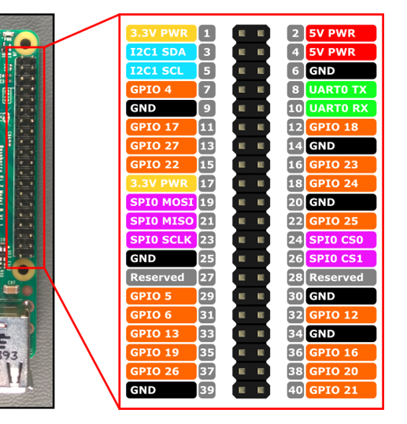

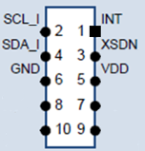

5 (SCL)

3 (SDA)

9 (GND)

5 (SCL)

3 (SDA)

25 (GND)

vl53l3cx @0x29

vl53l3cx @0x30

36 (GPIO16)

35 (GPIO19)

1 (3.3V)

11 (GPIO17)

13 (GPIO27)

17 (3.3V)

Ensure to have i2c support enabled on raspberry

Check in /boot/config.txt the following line

dtparam=i2c_arm=on

Keep gpio set in device tree overlay unexported:

echo 16 > /sys/class/gpio/unexport

echo 17 > /sys/class/gpio/unexport

echo 19 > /sys/class/gpio/unexport

echo 27 > /sys/class/gpio/unexport

# Driver compilation

The overlay shall be compiled by  
dtc -dtb duallx.dts -o duallx.dtbo

And shall be copied in /boot/overlays

sudo cp duallx.dtbo /boot/overlays/.

In the directory driver/vl53lx do:

make (for release < 1.1.0 type make VL53LX_FULL_KERNEL=1)

sudo dtoverlay -R

sudo dtoverlay duallx

sudo insmod stmvl53lx.ko

sudo chmod 777 /dev/stmvl53lx_ranging

sudo chmod 777 /dev/stmvl53lx_ranging1

/dev/stmvl53lx_ranging is the entry to use the first device (@0x30 on i2c)

/dev/stmvl53lx_ranging1 is the entry to use the second device (@0x29 on i2c)

expected output of i2cdetect command

pi@raspberrypi:~ $i2cdetect -r -y 1

0 1 2 3 4 5 6 7 8 9 a b c d e f

00: -- -- -- -- -- -- -- -- -- -- -- -- --

10: -- -- -- -- -- -- -- -- -- -- -- -- -- -- -- --

20: -- -- -- -- -- -- -- -- -- UU -- -- -- -- -- --

30: UU -- -- -- -- -- -- -- -- -- -- -- -- -- -- --

40: -- -- -- -- -- -- -- -- -- -- -- -- -- -- -- --

50: -- -- -- -- -- -- -- -- -- -- -- -- -- -- -- --

60: -- -- -- -- -- -- -- -- -- -- -- -- -- -- -- --  
70: -- -- -- -- -- -- -- --

build the phio tests application from android/hardware/vl53lx_test directory

make clean

make

At this stage commands can be used as shown in phio example source code.

Two instances of phio can be used,   
phio -d 0 <commands> to address /dev/stmvl53lx_ranging

phio -d 1 <commands> to address /dev/stmvl53lx_ranging1